

The Society for the Study of French History

<http://frenchhistorysociety.co.uk/>

<https://twitter.com/FrenchHistoryUK>

**Minutes of the Meeting of the SSFH Committee,**

**Lower Mezzanine Meeting Room, Senate House, London**

**Wednesday 15 January 2014**

**2.00 p.m.**

**Present:** Malcolm Crook (Chair), Sandy Wilkinson, Jessica Wardhaugh, Lori Oates, Ellen Crabtree, Mark Greengrass, Joe Bergin, Julian Wright, Dan Power, John Strachan, Penny Roberts, Noelle Plack, Chris Warne, Andrew Smith, Tim Baycroft, Stephen Tyre, Joanna Warson, Karine Varley, and Pamela Pilbeam.

1. Apologies for absence

Apologies were received from Linda Briggs, Robin Briggs and Joseph Clarke.

1. Minutes of previous committee meeting

The minutes of 30 June 2013 were approved by the committee.

1. Matters arising

The President, Malcolm Crook (MC), reported that we should follow up with Alison Carroll regarding the Society’s agreed annual support to the IHR French History Seminar - subject to the conditions set out in the minutes of 30 June. Sandy Wilkinson (SW) agreed to follow this up.

1. Report from the Secretary

SW reported on the deadlines for upcoming funding schemes for the Society and asked that the committee do their best to encourage applications. The deadline for the Research Grant Scheme is Friday 28th March 2014. The deadline for the Ralph Gibson Bursary scheme is 30 April 2014. The deadline for nominations for the undergraduate dissertation prize is 28 July 2014.

SW also reported on the number of awards made by the Society since October 2012 [Appendix I] and suggested that these be given greater visibility on the website. The amounts awarded would not be published.

SW raised the issue of reviewing our existing funding schemes and a robust general discussion of this issue followed. It was agreed by the committee to raise the award level for the research grant scheme from £750 to £1000 and that the Ralph Gibson award be raised from £2000 to £3000.

It was agreed that the terms and conditions of the Postgraduate Panel Prize be changed and that support could only be given to students registered to an HE institution in the UK or Ireland. In circumstances where the panel is composed of graduate students registered outside this area, a proportion of the cost may be awarded. In addition, the Scheme should have a deadline rather than be open for applications all year round.

There was a suggestion from Joe Bergin that the Society consider new ways of spending its income – perhaps subsidizing publishing projects or translation work. Julian Wright (JW) suggested developing a new research award aimed at outstanding postgraduate students and postdoctoral researchers. It was agreed that JW might bring plans in this area to the attention of the committee/AGM in July 2014.

There was some discussion of the Visiting Scholar Scheme and why it had attracted so few applications since its launch. Mark Greengrass (MG) suggested drawing attention to the Visiting Scholar scheme in H-France and AMHUF. Noelle Plack (NP) and Stephen Tyre (ST) suggested that it might be tied into networking opportunities which extended beyond the host institution. It could, perhaps, be linked to the Douglas Johnson Lecture.

Jessica Wardhaugh and Stephen Tyre (ST) raised the issue of advertising and marketing the Society’s schemes more broadly. It was agreed that the Society would use social networking in this area in addition to its existing mechanisms of drawing on its membership to publicse schemes and ensuring that the schemes were available in the standard forums – e.g. ResearchProfessional.com

1. Report from the Treasurer

Chris Warne, the Society’s Treasurer, submitted a statement of the Society’s accounts revealing that we are in robust financial health. These appear under Appendix II.

1. SSFH Grant Scheme Expenditure

Taken under section 4 above.

1. Report from Website Editor

MC moved to formalise Andrew Smith (AS)’s role as website actor. AS

had kindly agreed to serve as acting website editor when Kevin Gould stepped down from the role after many years of service. The nomination was approved unanimously. MC paid tribute to Kevin’s hard work and contribution.

It was remarked that the visuals on the website were dated. AS agreed to review this.

1. Report from Social Media Officer

Joanna Warson (JW) was confirmed unanimously as the new Social Media Officer taking over from AS. JW reported that the Society now has some 347 followers on Twitter and 138 likes on Facebook.

JW agreed to liaise with OUP, and to look into whether it may be worth buying social media advertising to promote the work of the Society and its various funding schemes.

1. Report from the Membership Secretary

NP reported that a snapshot of membership numbers at the present reveals a significant drop compared with last year – 92 versus 147.

It was noted that this is likely to be seasonal, and that numbers are likely to rise again in the run up to the Society’s conference.

9.5 Report of the Editors of French History

A report from the editors of the Journal was tabled by JW. Please see Appendix III. A discussion followed regarding the proposal to host a meeting of the full editorial board at the Society’s annual conference in Durham. There was general support for this. Joe Bergin noted that OUP should also be approached about contributing to this.

JW noted that he would attend a meeting on Open Access on 11 February and would report back.

Jessica Wardhaugh noted that the flow of copy for the news section was good. Her proposal to have a single short 400-word report on the outcome of Society-funded activities was endorsed by the committee, as was her request that holders of the Ralph Gibson Bursary also be required to write a report. The terms and conditions of awards will be changed to reflect this decision.

1. Conference Matters

MC thanked Kevin Passmore and all those who had been involved in organising an enjoyable and hugely successful conference in Cardiff in 2014.

JW and Karine Varley (KV) reported that plans were at an advanced stage for this year’s conference to be held in Durham 10-12 July. There was a disappointing response to the first call for papers, but the deadline was now extended to the third week of February. Social media would also be employed to encourage submissions.

ST raised the issue of whether it would be possible for the Society to look at agreeing to underwrite a proportion of the postgraduate/unwaged fee income for the St Andrews Conference. MC agreed to look at a detailed proposal on this from ST.

1. Douglas Johnson Annual Lecture in French History 2015

MC confirmed that Professor John Horne (TCD) had agreed to offer the Douglas Johnson Lecture in 2015. This will take place on Wednesday 14 January 2015.

Pam Pilbeam proposed that we reflect on the title of the lecture as it may be deterring younger scholars unfamiliar with Douglas Johnson’s contribution to French scholarship. The consensus seemed to be in favour of leaving the title as it stood, but ensuring that the last part – in French History – be given due prominence.

A general discussion followed noting the importance of broad publicity for the event to attract London’s broad base of historians.

1. Postgraduate representatives

Ellen Crabtree reported that plans for the study day were progressing well. Last year, 6-7 abstracts were received compared with 17 this year. There was a request for further funding, which would be matched by its sister society the ASMCF. It was agreed that 750 GBP be awarded by the SSFH to support this event.

1. Trustees and Presidency

MC thanked both Bill and Pam for their dedicated and long-standing service to the Society.

He recorded that both Penny Roberts and Dave Andress have been invited to serve as Trustees from July 2014.

MC also noted that his term as President would come to an end at the next conference, and that a successor would be required.

1. Committee Composition a) Treasurer b) Social Media Officer c) Postgraduate Representatives

Andrew Smith was confirmed as the new website editor.

Joanna Warson was confirmed as the new Social Media Officer.

Lori Oates and Ellen Crabtree were confirmed as the new postgraduate representatives.

Following the successful defence of her thesis, Linda Briggs would be invited to serve on the committee as an ordinary member.

MC asked for permission to seek a new Treasurer to replace Chris Warne who has stood down from the position after a substantial period in the post. MC thanked Chris for his invaluable service and contribution to the Society.

1. Date of next Committee Meeting

This was confirmed as Thursday 10 July 2014. The AGM will take place on 12 July 2014.

1. Any Other Business

Mark Greengrass reported on the good health of the MUP series, but strongly encouraged submission of proposals from senior scholars. The committee’s help in securing proposals was sought. Mark noted that the term of the two series editors was coming to an end and that replacements would need to be found. Tim suggested that a more phased replacement might be more beneficial. Both Pam and Mark agreed that this would be a sensible way to proceed.

MC asked for proposals and nominations to be sent directly to him.

The final piece of business was a proposal to make both Pam and Robin life members of the Society – a proposal approved unanimously by the committee.

SW agreed to follow up on this with OUP.

**Appendix I**

**RECENT AWARDS MADE BY THE SOCIETY**

**Postgraduate Conference Panel Scheme**

Stewart McCain (Oxford) Modernity and its Discontents in Nineteenth-Century France’ at the Society for French Historical Studies Conference in Montreal in April 2014

**Conference Grant Scheme**

Bryce Evans (Liverpool Hope) ‘Food and the First World War’, Liverpool Hope University in 2014.

Mark Greengrass (Sheffield), ‘Fortune, pouvoir, et croyance: L’Eglise en France aux XVIe-XVIIe siècles’, 27-28 September 2014.

Sarah Wood ‘Locating Guyane’, University of London Institute in Paris (ULIP), 10-11 July 2014.

Hanna Diamond (Bath), ‘70th Anniversary of the Liberation of France’, Institut Français, London, 13-14 June 2014.

Phil McCluskey (Sheffield), for ‘Contacts, encounters, practices: Ottoman-European diplomacy, 1500-1800’, St Andrews, June 2014

John Condren (St Andrews) 'France and the Mediterranean World in the Long Seventeenth Century' , St Andrews, May 2014.

Sara Wolfson (Manchester Metropolitan) ‘Anglo-French and Anglo-Spanish marriage negotiations’, Kent, April 2014.

Iain Stewart (Queen Mary) ‘New Perspectives on the French Liberal Renaissance’, University of London Institute, Paris, 7 December 2013.

Rachel Douglas (Glasgow) ‘Rewriting French and CaribbeanHistory: The Black Jacobins Revisited’, October 2013

Marieke Dubbelboer (Bristol), ‘*Writers and the Press in France: Pamphlets, Propaganda, and Politics’*, September 2013.

Edward Roberts (St Andrews) ‘Politics and Texts in Late Carolingian Europe, c. 870-1000’, University of St Andrews, 8-9 July 2013.

Alison Carroll (Brunel), 'A Century Later: New Approaches to French History, 1914-45', Maison Française d’Oxford 21 June 2013.

**Ralph Gibson Bursary**

The Ralph Gibson Bursary Prize was awarded in 2013 to Will Pooley of New College, Oxford to support his work on ‘Misery in the Moorlands': Lived Bodies in the Landes de Gascogne, 1870-1914’.

**CONFERENCE BURSARIES**

Kristin Bourassa (York), to attend the SFHS conference in Montreal in 2014

Ellen Crabtree (Newcastle), to attend the SFHS conference in Montreal in 2014

Lori Oates (Exeter) to attend a conference in Gothenburg in 2013

Charlotte Faucher (Queen Mary)

Kate Hammond (St Andrews)

**Research Grant Scheme 2013**

Will Clement (Oxford)

Fiona Ffoulkes (Southampton)

Stefania Gargioni (Kent)

Alessandro Gnasso (Edinburgh)

Jan de Graaf (Portsmouth)

Anna Jenkin (Sheffield)

Niall MacGalloway (St Andrews)

Martha McCarey (Oxford)

Lori Oates (Exeter)

Imaobong Umoren (Oxford)

Elisabeth Wallman (Warwick)

Bernard Wilkin  (Sheffield)

Jacob Zobkiw (Hull)

**APPENDIX II**

**SOCIETY ACCOUNTS**

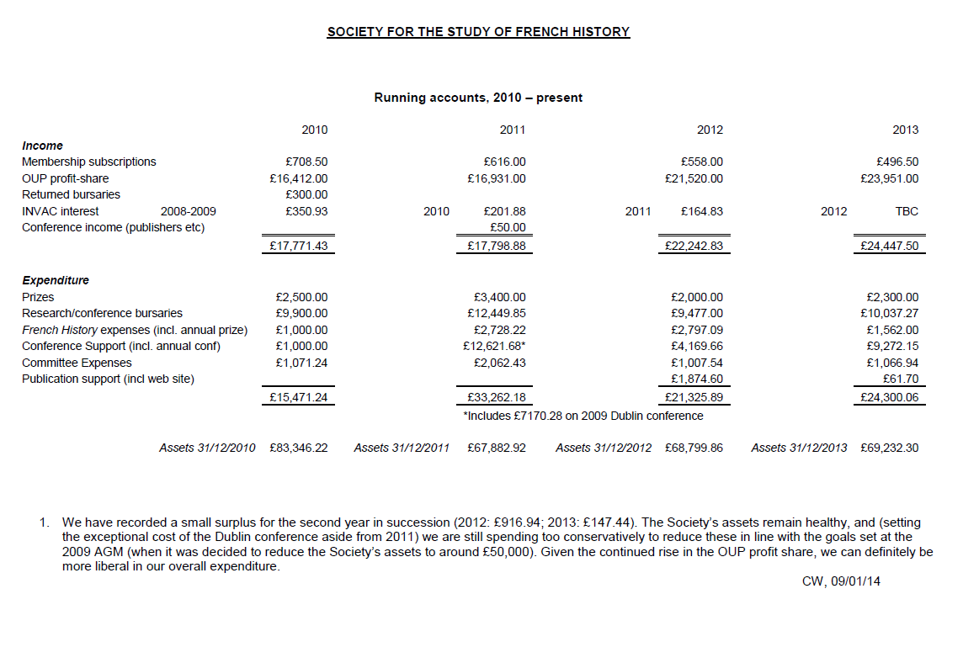

**APPENDIX III**

***French History* Editors’ report to SSFH Committee, January 2014**

The tables below were prepared by our Virtual Editorial Office Assistant who helps keep the management of our online submission site running smoothly.

Her work shows the growth in submission of Book reviews under Tim Baycroft’s leadership, and the significant bulge in 2012 probably reflects a number of items that he was able to process expeditiously with the new assistance that was in place in that year, helping to stabilize and streamline his processes at Sheffield. We expect that this has now settled and that Tim’s support systems have finally helped to deliver the predictability and stability in copy flow that he needs to manage the book reviews section. There is a ‘buffer’ of a whole issue’s worth of reviews, which means that reviews can be selected for each issue with greater control over the spread and balance of material.

Article submission remains stubbornly around 40. Within this, overall quality has increased; judging for the annual article prize certainly confirms that. There are also a few more outstanding articles by senior scholars coming our way. The spread is highly satisfactory, too (most of the UK figures in the country-by-country table reflect book review authors, of course).

However, this does suggest that our present policy of 5 articles per issue should remain the same. We need to continue to exercise control on word-length as we were unable to publish book reviews in December 2013. In order to make a significant step forward in terms of increasing article submission rates we would need to develop a fresh strategic approach.

We have a number of very worthwhile special issues in hand, including the December 2013 issue on cultural encounters which is fascinating, provocative and high quality – and shows a really helpful branching into more transnational themes. Forthcoming are issues on: animals in French history; France and the Mediterranean in the early modern period; and elections and electoral practices in modern French history. These special issues have again helped to keep a ‘buffer’ of more than 1 issue so that we can make up future ‘normal’ issues from a pool of material that is already published in advance online access.

However, we would hope that planning special issues would allow us to exercise greater selectivity over a continuing flow of submissions, rather than replacing some of that flow.

We hope to hold a full Board meeting prior to the Durham Conference on 10 July in order to address this and will apply to the SSFH for funding to help bring some Board members who might not have been planning to attend the conference to Durham.

**By Manuscript Type**

|  |  |  |  |  |  |  |  |
| --- | --- | --- | --- | --- | --- | --- | --- |
| **Number of Manuscripts** | 2008 | 2009 | 2010 | 2011 | 2012 | 2013 | **Summary** |
| Article | 37 | 36 | 40 | 39 | 42 | 39 | **233** |
| Book Review | 29 | 29 | 39 | 51 | 138 | 79 | **365** |
| Other | 1 | 1 | 4 | 6 | 4 | 5 | **21** |
| Review Article |  |  | 3 |  |  | 1 | **4** |
| **Summary** | **67** | **66** | **86** | **96** | **184** | **124** | **623** |

### By Country of Origin

|  |  |  |  |  |  |  |  |
| --- | --- | --- | --- | --- | --- | --- | --- |
| **Number of Manuscripts** | 2008 | 2009 | 2010 | 2011 | 2012 | 2013 | **Summary** |
| Australia | 2 | 2 | 8 | 7 | 15 | 6 | **40** |
| Belgium | 2 | 2 | 1 |  | 1 | 4 | **10** |
| Canada | 7 | 2 | 8 | 2 | 3 | 7 | **29** |
| Finland |  |  |  |  | 1 |  | **1** |
| France | 7 | 8 | 13 | 10 | 11 | 10 | **59** |
| Germany | 1 |  |  |  | 1 | 2 | **4** |
| Greece |  |  | 1 |  |  |  | **1** |
| India |  | 2 |  |  |  |  | **2** |
| Ireland | 1 | 2 | 4 |  |  | 2 | **9** |
| Israel | 2 |  |  |  | 1 |  | **3** |
| Italy |  |  | 2 | 1 |  | 1 | **4** |
| Netherlands | 5 | 2 |  |  | 1 | 1 | **9** |
| New Zealand |  |  |  | 1 | 1 |  | **2** |
| Portugal |  |  |  |  |  | 2 | **2** |
| Russian Federation |  |  |  |  | 1 |  | **1** |
| Spain | 1 |  | 1 |  | 2 |  | **4** |
| Sweden |  |  |  |  | 2 |  | **2** |
| Switzerland | 1 |  | 1 |  |  |  | **2** |
| United Arab Emirates |  |  | 1 |  |  |  | **1** |
| United Kingdom | 29 | 32 | 41 | 58 | 78 | 62 | **300** |
| United States | 9 | 14 | 5 | 16 | 65 | 27 | **136** |
| **Summary** | **67** | **66** | **86** | **95** | **183** | **124** | **621** |

|  |  |  |  |  |  |  |  |  |
| --- | --- | --- | --- | --- | --- | --- | --- | --- |
| **Number of Manuscripts** | Accept | | Reject | | Revise | | | **Summary** |
| Accept | **Accept** | Reject | **Reject** | Major Revision | Minor Revision | **Revise** |
| Baycroft, Tim | 63 | **63** |  |  |  |  |  | **63** |
| Roberts, Penny |  |  | 5 | **5** | 5 | 3 | **8** | **13** |
| Wright, Julian | 5 | **5** | 6 | **6** | 5 | 9 | **14** | **25** |
| **Summary** | **68** | **68** | **11** | **11** | **10** | **12** | **22** | **101** |

## Time from Submission to First Decision Year to Date

|  |  |  |  |  |
| --- | --- | --- | --- | --- |
| |  | | --- | | Editor | | Decision | Number of Manuscripts | Average Days |
| Baycroft, Tim | Accept | 63 | 47.95 |
| **Baycroft, Tim** | | **63** | **47.95** |
| Roberts, Penny | Major Revision | 5 | 91.60 |
| Minor Revision | 3 | 23.00 |
| Reject | 5 | 73.04 |
| **Roberts, Penny** | | **13** | **68.70** |
| Wright, Julian | Accept | 5 | 9.60 |
| Major Revision | 5 | 69.20 |
| Minor Revision | 9 | 87.11 |
| Reject | 6 | 33.96 |
| **Wright, Julian** | | **25** | **60.15** |
| **Summary** | | **101** | **56.94** |

**AVERAGE TIME FROM SUBMISSION TO FIRST DECISION FOR 2013 IS 64.42 DAYS**

**The average time from Submission to Decision for Book Reviews is 47.95 days**